**Aim:- Programing Multiple Activities and fragments.**

**Activity_main.xml –**

*<?*xml version="1.0" encoding="utf-8"*?>*<androidx.constraintlayout.widget.ConstraintLayout xmlns:android="http://schemas.android.com/apk/res/android"  
 xmlns:app="http://schemas.android.com/apk/res-auto"  
 xmlns:tools="http://schemas.android.com/tools"  
 android:layout_width="match_parent"  
 android:layout_height="match_parent"  
 tools:context=".MainActivity">  
  
 <TextView  
 android:id="@+id/textView"  
 android:layout_width="wrap_content"  
 android:layout_height="wrap_content"  
 android:text="Page 1"  
 android:textSize="50dp"  
 android:textColor="@color/black"  
 app:layout_constraintBottom_toBottomOf="parent"  
 app:layout_constraintEnd_toEndOf="parent"  
 app:layout_constraintHorizontal_bias="0.564"  
 app:layout_constraintStart_toStartOf="parent"  
 app:layout_constraintTop_toTopOf="parent"  
 app:layout_constraintVertical_bias="0.176" />  
  
 <Button  
 android:id="@+id/btn1"  
 android:layout_width="wrap_content"  
 android:layout_height="wrap_content"  
 android:text="Next Page"  
 android:textSize="30dp"  
 app:layout_constraintBottom_toBottomOf="parent"  
 app:layout_constraintEnd_toEndOf="parent"  
 app:layout_constraintStart_toStartOf="parent"  
 app:layout_constraintTop_toTopOf="parent"  
 app:layout_constraintVertical_bias="0.499" />  
  
</androidx.constraintlayout.widget.ConstraintLayout>

**Page1.kt Code:–**

package com.example.multipleactivity  
  
import androidx.appcompat.app.AppCompatActivity  
import android.os.Bundle  
import android.widget.Button;  
import android.content.Intent;  
import kotlinx.android.synthetic.main.activity_main.*  
  
class MainActivity : AppCompatActivity() {  
  
 override fun onCreate(savedInstanceState: Bundle?) {  
 super.onCreate(savedInstanceState)  
 setContentView(R.layout.*activity_main*)  
 btn1.setOnClickListener**{** val intent = Intent(this,Page2 :: class.*java*)  
 startActivity(intent)  
 **}** }  
  
}

**Output:-**

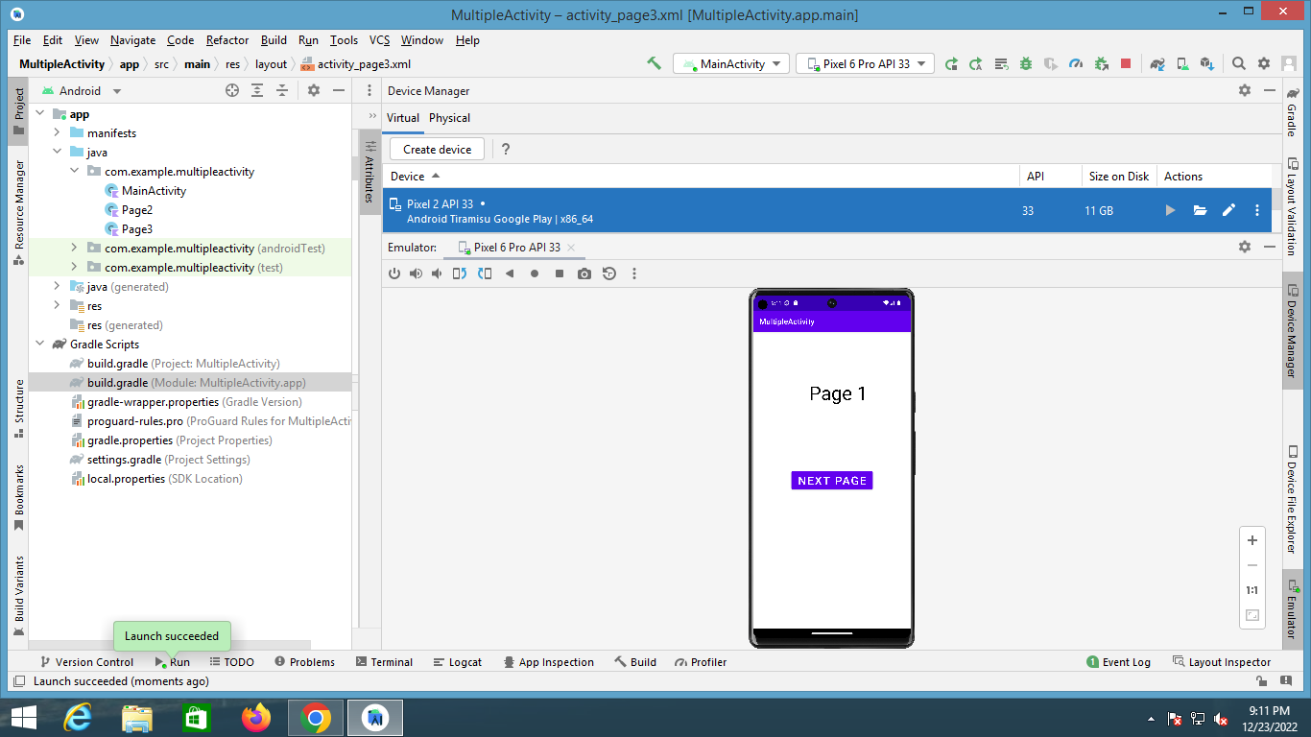

**Page 2 Activity xml code:-**

*<?*xml version="1.0" encoding="utf-8"*?>*

<androidx.constraintlayout.widget.ConstraintLayout xmlns:android="http://schemas.android.com/apk/res/android"

xmlns:app="http://schemas.android.com/apk/res-auto"

xmlns:tools="http://schemas.android.com/tools"

android:layout_width="match_parent"

android:layout_height="match_parent"

tools:context=".Page2">

<TextView

android:id="@+id/textView"

android:layout_width="wrap_content"

android:layout_height="wrap_content"

android:text="Page 2"

android:textSize="50dp"

android:textColor="@color/black"

app:layout_constraintBottom_toBottomOf="parent"

app:layout_constraintEnd_toEndOf="parent"

app:layout_constraintHorizontal_bias="0.564"

app:layout_constraintStart_toStartOf="parent"

app:layout_constraintTop_toTopOf="parent"

app:layout_constraintVertical_bias="0.176" />

<Button

android:id="@+id/btn2"

android:layout_width="wrap_content"

android:layout_height="wrap_content"

android:text="Next Page"

android:textSize="30dp"

app:layout_constraintBottom_toBottomOf="parent"

app:layout_constraintEnd_toEndOf="parent"

app:layout_constraintStart_toStartOf="parent"

app:layout_constraintTop_toTopOf="parent"

app:layout_constraintVertical_bias="0.499" />

</androidx.constraintlayout.widget.ConstraintLayout>

**Page2.kt code:-**

package com.example.multipleactivity  
  
import android.content.Intent  
import androidx.appcompat.app.AppCompatActivity  
import android.os.Bundle  
import kotlinx.android.synthetic.main.activity_main.*  
import kotlinx.android.synthetic.main.activity_page2.*  
  
class Page2 : AppCompatActivity() {  
 override fun onCreate(savedInstanceState: Bundle?) {  
 super.onCreate(savedInstanceState)  
 setContentView(R.layout.*activity_page2*)  
 btn2.setOnClickListener**{** val intent = Intent(this,Page3 :: class.*java*)  
 startActivity(intent)  
 **}** }  
}

**Output:-**

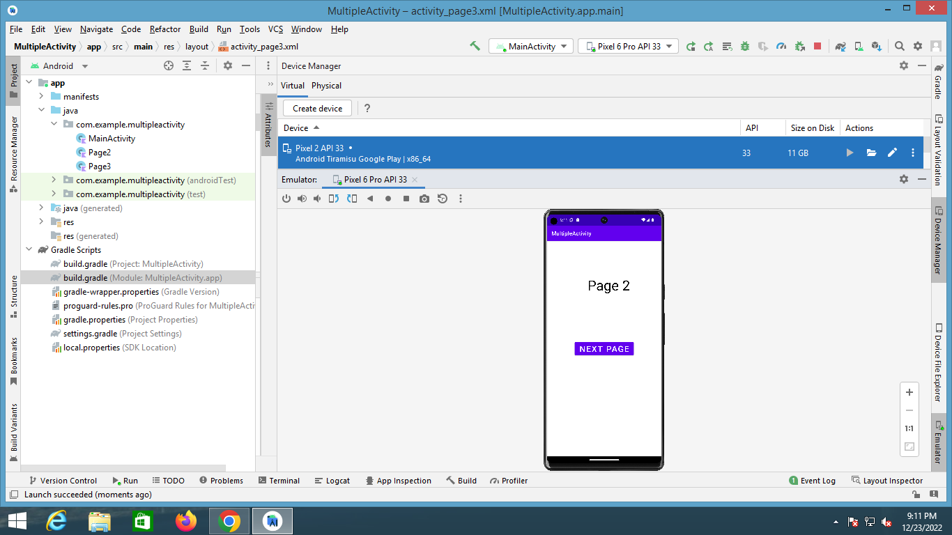

**Page 3 Activity xml code:-**

*<?*xml version="1.0" encoding="utf-8"*?>*

<androidx.constraintlayout.widget.ConstraintLayout xmlns:android="http://schemas.android.com/apk/res/android"

xmlns:app="http://schemas.android.com/apk/res-auto"

xmlns:tools="http://schemas.android.com/tools"

android:layout_width="match_parent"

android:layout_height="match_parent"

tools:context=".Page3">

<TextView

android:id="@+id/textView"

android:layout_width="wrap_content"

android:layout_height="wrap_content"

android:text="Page 3"

android:textSize="50dp"

android:textColor="@color/black"

app:layout_constraintBottom_toBottomOf="parent"

app:layout_constraintEnd_toEndOf="parent"

app:layout_constraintHorizontal_bias="0.564"

app:layout_constraintStart_toStartOf="parent"

app:layout_constraintTop_toTopOf="parent"

app:layout_constraintVertical_bias="0.176" />

<Button

android:id="@+id/btn3"

android:layout_width="wrap_content"

android:layout_height="wrap_content"

android:onClick="Next"

android:text="Next Page"

android:textSize="30dp"

app:layout_constraintBottom_toBottomOf="parent"

app:layout_constraintEnd_toEndOf="parent"

app:layout_constraintStart_toStartOf="parent"

app:layout_constraintTop_toTopOf="parent" />

</androidx.constraintlayout.widget.ConstraintLayout>

**Output:-**

